**Description**

As a user I must have ability to view Contact Us page.

------------------------------------------------------------------------------------------------------------------------------------------

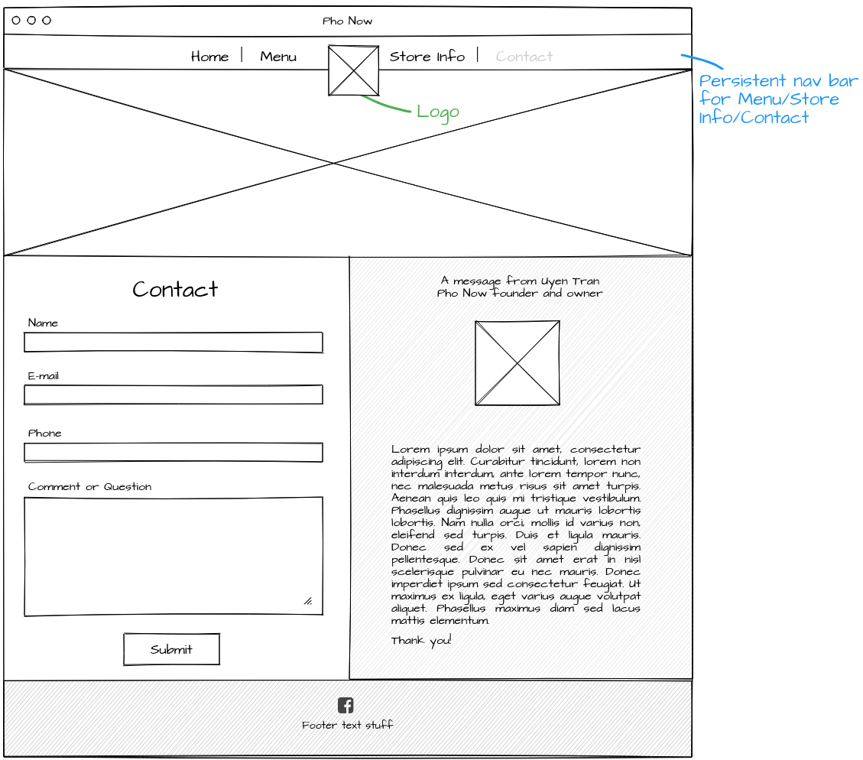

**Acceptance criteria**

* Display Contact form with Name , Email, Phone and Comments input fields.
* Display message from owner.
* Display Submit button .